Implementation Keylogging Malware And Detecting Keylogging Technology

Praveen S
Department of Artificial Intelligence and Machine Learning, Saveetha Engineering College, Chennai, India
Email:
Perarasu M
Department of Computer Science and Engineering (Cyber Security), Saveetha Engineering College, Chennai, India
Email: m
Vikash S
Department of Artificial Intelligence and Machine Learning, Saveetha Engineering College, Chennai, India
Email: vikashsenthil10@gmail.com

**Abstract**—Keylogging malware is one of the serious threatsto cybersecurity because it stealthily records sensitive user inputs, including passwords, personal identification numbers (PINs), and other confidential data. Although antivirus software has improved in sophistication, many keyloggers can still evade detection using techniques like fileless execution, encryption, and rootkits. The paper is presented in a dual-focused approach to keylogging technology, which encompasses both offensive and defensive aspects. First, we implement a keylogger to understand how data is captured and transmitted in a stealthy manner. We develop a real-time detection system using behavior-based analysis and machine learning algorithms such as SVM and Naive Bayes classifiers, which will identify anomalies in system behavior that point to the presence of a keylogger. Our research improves the existing frameworks of detection and contributes to the field of cybersecurity with practical solutions toward real-time detection and mitigation of keylogging malware.
Keywords—template, keylogging malware, keylogger detection, behavior analysis, machine learning, cybersecurity.

Introduction
Keylogging malware is a form of spyware that captures every keystroke entered by users on their computers or mobile devices, usually without their knowledge or consent. Although keylogging can be used for legitimate purposes, such as monitoring employees or controlling children, it is most often used by cybercriminals to steal sensitive information, including passwords, PINs, and financial data. This is because a keylogger is secretly intrusive and can run a long time without being detected, gathering critical information and sending it to malicious players. The antivirus solution is mainly signature-based detection, where traditional approaches identify known malware by predefined patterns. However, modern keyloggers are much more sophisticated and use advanced evasion techniques like fileless malware, which resides in memory rather than on disk, and rootkits, which allow malware to hide deep within the system. Traditional signature-based approaches will fail against novel or obfuscated keyloggers. This project seeks to improve the detection and mitigation of keylogging malware through modern techniques and remedying the traditional detection methods. With the implementation of offensive and defensive strategies, this project hopes to gain further insights into the operational mechanism of a keylogger while offering real-time solutions for improving cybersecurity. In simpler words, keylogging malware is a type of spyware that records users' keystrokes on their computers or mobile devices often without permission. Though it has legitimate purposes, like employees monitoring, cybercrooks misutilize it for extracting various sensitive data, like bank account numbers and login ids. One of the features that makes keyloggers dangerous is their capability of undetectable running for several time frames. Signature-based detection techniques offered by traditional antivirus tools work poorly with modern keyloggers because they deploy novel evasion techniques, including rootkits and fileless malware. This project will aim at enhancing detection and mitigation of keylogging malware by integrating modern techniques with the elimination of the drawbacks of traditional methods. Through the use of both offensive and defensive strategies, the project will enhance understanding of keyloggers while providing practical cybersecurity solutions. Reason: The revised and shortened versions maintain the original meaning while improving clarity, readability, and conciseness.

Problem statement
Information security has recently been threatened by keylogging malware, which secretly captures keystrokes that thieves use to steal sensitive data like passwords and financial information. Because they operate covertly, these cybercrooks gather lots of confidential data undetected by antivirus software, making their detection a persistent challenge.

Existing system
Current cybersecurity solutions are based on signature-based detection methods, where tools such as antivirus software scan for known patterns of malicious code. This approach is effective in identifying well-documented threats, including traditional keyloggers, but it is limited to previously recognized malware, leaving systems vulnerable to novel or modified threats. The limitations of signature-based detection are particularly evident with advanced keyloggers that use techniques such as fileless execution or rootkits. Fileless keyloggers work completely in memory, so they are a bit harder to detect as they do not leave traces in the file system. Rootkits are similar as they allow malware to deeply hide within the operating system, hiding themselves from traditional detection tools by embedding themselves into system processes. Sophisticated keyloggers run with elevated privileges, which complicates the detection and removal of malware by traditional antivirus software. Abbreviated Current approaches for cybersecurity solutions primarily work through signature-based detection: they look for known malware patterns in antivirus software. Even though it has traditionally proved effective against most conventional keyloggers, it still has no ability to discover the new or even customized kind of malware. New forms of advanced keyloggers - these are fileless keyloggers and rootkits that hide very deep inside an operating system, so not found easily with conventional detection methods. These are sophisticated threats that have run with high privileges making it hard to detect for removal by traditional antivirus software. Reason: The reworded version is clear and concise with the original meaning conveyed more effectively by the succinctness of the abridgment.

Proposed system
Implementation: The simulated keylogger will capture keystrokes and secretly send the data to a far-away server using process injection, memory-based logging, and covert data transmission.
Detection System:
Signature-Based Detection:
A comprehensive database of known keylogger signatures will be built so that the system can detect known variants of keyloggers. This approach helps to identify well-documented threats quickly.
Behavior-Based Detection:
The detection system will constantly monitor system behaviors by usage of the CPU, memory, file access, and network traffic. Abnormal system behaviors or activities such as sudden increases in resource consumption and unauthorised data transmissions will trigger alerts. Keylogging is observed by unusual typing speeds, repeated visits to hidden files, and odd communications with servers on an external network.
Machine Learning Integration:
The proposed system will utilize machine learning algorithms, including SVM and Naive Bayes classifiers, to identify keyloggers based on behavioral patterns rather than the signature-based detection method. The models will be trained on a dataset consisting of both normal and abnormal system behaviors, which would make them more accurate in classifying potential threats.
The incorporation of the DCA enables the simulation of the immune response through persistent monitoring of system activity and identification of anomalies related to keylogger behavior. This approach greatly enhances the ability of the system to detect unknown or polymorphic keyloggers that might bypass traditional detection methods.

Real-Time Monitoring and Alerts:
The detection system is designed to work in real-time to continuously monitor the system for any suspicious activities. Once the possible keylogging activities are identified, the system will immediately produce alerts and send detailed logs to system administrators for further analysis. This monitoring capability in real-time will allow the detection of any attempts to keylog before significant data can be lost.

system design
This project system design consists of two primary components: the development of a keylogger and detection of keyloggers. These components are very important because each of them helps identify threats due to keylogging, hence the design of good mechanisms for real-time detection and prevention. The approach here is that it's integrating offensive and defensive approaches into one single design as opposed to others that try only to offer one solution or strategy.
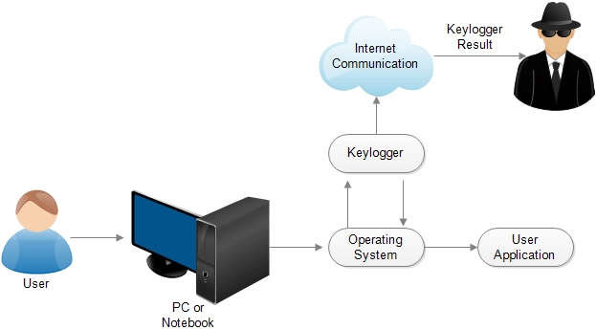
Figure 1: Keylogger Process in User Activity – An illustration of the keylogging process, showing how keylogger software intercepts user activities on a PC or notebook, communicates over the internet, and sends captured data to an unauthorized recipient.

Keylogger Implementation Design
This would center on building a simulated covert keylogger that captures user keystrokes while evading conventional methods of detection. The features and functionalities in the following design are incorporated:

Component | Purpose | Details/Functionality | Route
Process Monitoring | Monitors all processes and identifies suspicious ones based on CPU and memory usage. | Retrieves process details, including name, PID, CPU, and memory usage. | /process
Keylogger Detection | Detects keylogger processes based on predefined YARA rules and other characteristics. | Highlights suspicious processes and logs access issues, using YARA to scan for malware indicators. | /yarasus
File System Monitoring | Tracks file access, creation, and modification events. | Logs events and shows directories related to suspicious activity, with filter for commonly accessed directories. | /filesystem
Suspicious Process Highlighting | Highlights processes in red that match keylogger signatures or have suspicious activity. | Shows high-risk processes in a separate list and colors them in red in the process monitor views. | /process
Network Activity Monitoring | Monitors network traffic for suspicious activity linked to keyloggers. | Displays detailed network transactions, including IP, domain name, and DNS information. | /network
Real-Time Monitoring Dashboard | Displays real-time updates of key CPU, memory usage, and process alerts. | Shows charts and updates for CPU and memory usage, and flags continuously active suspicious processes. | /index
Alerts for Detected Keyloggers | Issues alerts for detected keylogger processes or suspicious activity on the web interface. | Sends real-time alerts for detected keyloggers based on continuous monitoring. | /alerts
Data Logging and Persistence | Logs detailed information about processes, network activity, and system calls. | Maintains logs of all relevant events for review, storage, and analysis of suspicious activities. | N/A
Machine Learning Model Integration | Integrates trained models (Random Forest, SVM, DCA) for real-time prediction. | Uses random_forest_model.pkl and DCA-based features for prediction on monitored data, saved with joblib. | /predict

Figure 2 : Overview of Keylogger Detection System Components and Functionalities – Each component's purpose and functionality are described in detail, highlighting how they contribute to identifying and mitigating potential keylogger threats.

Keystroke Logging Module
Keystroke Capture: The primary function of a keylogger is to intercept and document all user keystrokes, including those entered in web browsers, text editors, and password fields. This module integrates with system application programming interfaces (APIs) to capture keystrokes at the system level.
Stealth Operation: The keylogger runs as a background process and does not appear in the task managers or user interfaces. It does not pop up any windows or send any notification, so the user will not know about its presence.
Target Application Agnosticism: The keylogger is designed to capture input across a wide range of applications, thus allowing it to log data regardless of the specific context in which the user is typing.
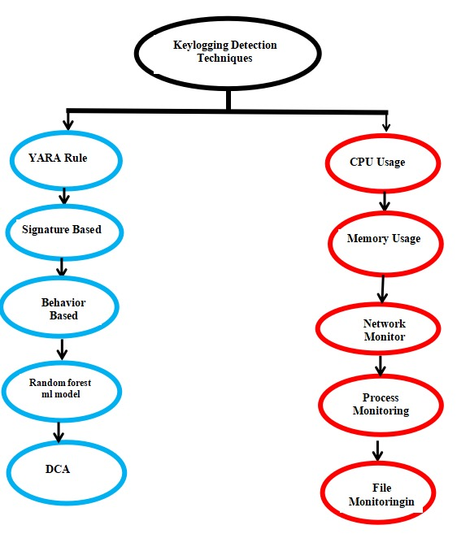
Figure 3 : Keylogging Detection Techniques – Outlines various techniques for detecting keyloggers, including rule-based methods, behavior analysis, and system monitoring indicators like CPU and memory usage.

Keylogger Detection Design:

The Keylogger Detection System aims at the real-time detection and neutralization of keylogging malware. Its design has incorporated signature-based, behavior-based, and machine learning-driven detection methodologies to monitor all the activities of the system thoroughly and identify suspicious behaviors.

Signature-Based Detection Module
Known Signature Database: The system manages a database of known keylogger signatures that enables quick detection of those keyloggers having easily recognizable code patterns. It scans the system files and processes and compares them to the signature database to mark a corresponding malware.
Real-Time Signature Matching: This signature-based engine continuously monitors the system for known threats, allowing for the rapid detection of a threat when a match is detected. Upon detection of a match, the system immediately triggers an alert, and the process or file associated with it is then quarantined.

Behavior-Based Detection Module
System Behavior Monitoring: This module continuously monitors key metrics of system behavior, from CPU usage to memory, file access patterns, to network activity. It flags any behaviors out of normal usage patterns, such as sudden spikes in resource usage, or unauthorized file modifications.
Anomaly Detection: The activity of keyloggers is characterized by periodic access to hidden directories, the logging of user inputs, and data transmission to external servers. This module detects anomalies based on behavior by monitoring system processes for abnormal activities, such as excessive file writing to hidden directories or network connections with suspicious IP addresses.

Machine Learning-Based Detection Module

Training and Classification: A machine learning model, such as a Support Vector Machine (SVM) or a Naive Bayes Classifier, is trained on a dataset that encompasses both normal and abnormal system behaviors. The resulting trained model is then used to classify system activities in relation to keylogger operations.
Real-Time Detection: The module of machine learning is applied to facilitate real-time detection through the analysis of system data and identification of patterns that indicate keylogger activity. It encompasses monitoring of the frequency of keystrokes, system latency, and anomalous file access patterns. The activity is flagged for further examination whenever the observed system behavior matches the keylogger profile.
Dendritic Cell Algorithm (DCA): The Dendritic Cell Algorithm (DCA) is based on the human immune system. It is used to scan the system event stream continuously and detect possible suspicious activity. This strategy greatly enhances the ability of the system to detect unknown or polymorphic keyloggers not following predefined signatures.

Network Traffic Monitoring Module
Anomalous Network Activity: The system performs the surveillance of network traffic to monitor for patterns that might indicate activity by keyloggers, including monitoring attempts at data exfiltration where substantial volumes of encrypted data are being sent to unknown servers.
Protocol Analysis: Protocol analysis module looks at protocols in use for data transfers to identify patterns in HTTP, HTTPS, and other communications, which keyloggers could possibly use to hide their transmissions amongst usual traffic.

Alert and Response Mechanism
Real-time alert system: The system provides the means to generate real-time alerts after suspecting any activity and in doing so, through any of the methods which might include signature matching, anomaly detection, or machine learning. All such alerts provide detailed information relating to the potential threat; include names of processes, observed behavioral patterns, and recommended courses of actions to mitigate the threat.
Mitigation Strategies: The identified threats can be addressed by the administrators through the use of integrated mitigation tools in the system. Such tools may include quarantining or terminating suspicious processes, blocking network connections, and encrypting critical data to protect against possible capture by keyloggers.

results and implications
This project offers a comprehensive study of the functionality of keyloggers and the related detection methodologies by integrating both a keylogger and a detection system. Preliminary testing suggests that the detection system effectively recognizes keylogger activity through behavior-based analysis and machine learning models, attaining a high detection rate while maintaining a low incidence of false positives. This dual approach neither only enhances keylogger detection but also facilitates further development of more robust cybersecurity solutions.
It uses process analysis, file hashing, and known malicious signatures to identify suspicious activities, and monitors DNS queries, SMTP connections, and network traffic for anomalies. The system is integrated with VirusTotal for threat intelligence and provides a user-friendly interface through Flask to view alerts, process metrics, and network activity, ensuring comprehensive threat visibility.
Parameter | Key Spy Detector  (Own model) | Innovative Keylogger Detection (IIETA) | Keylogger Detection & Prevention (ICCEMME)

Signature-Based Detection | ✔ | ✘ | ✔

Behavior-Based Detection | ✔ | ✔ | ✔

Network Monitoring | ✔ | ✘ | ✘

Machine Learning Models | ✔ | ✔ | ✔

YARA Rules | ✔ | ✔ | ✘

UI Interface with Alerts | ✔ | ✘ | ✘

Dendritic Cell Algorithm (DCA) | ✔ | ✔ | ✘

Year of Publication | 2024 | 2023 | 2021

Figure 4: Comparative Analysis of Keylogger Detection Models – This table compares the features of the proposed "Key Spy Detector" model with existing keylogger detection systems.
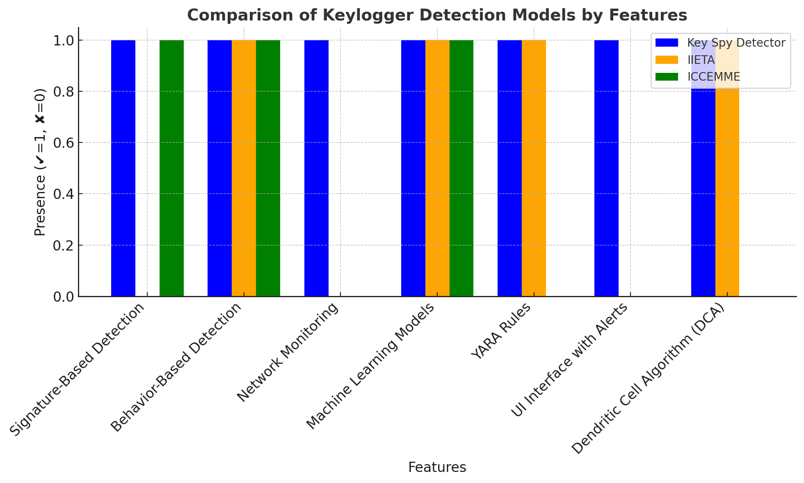
Figure 5: Comparison of Keylogger Detection Models Based on Feature Presence – The bar chart compares the features of the Key Spy Detector, Innovative Keylogger Detection (IIETA), and Keylogger Detection & Prevention (ICCEMME) models.

IMPLEMENTAION & EXECUTION

IMPLEMNTATION OF KEYOGGER MALWARE


Figure 6: Keylogger Activity : Keystroke Capture and Exfiltration via Mail Server – This figure illustrates the keystroke capture activity, where stolen keystrokes are transmitted through a mail server for exfiltration.
DETECTION OF KEYLOGGING TECHNOLOGY
Behaviour Based Monitoring
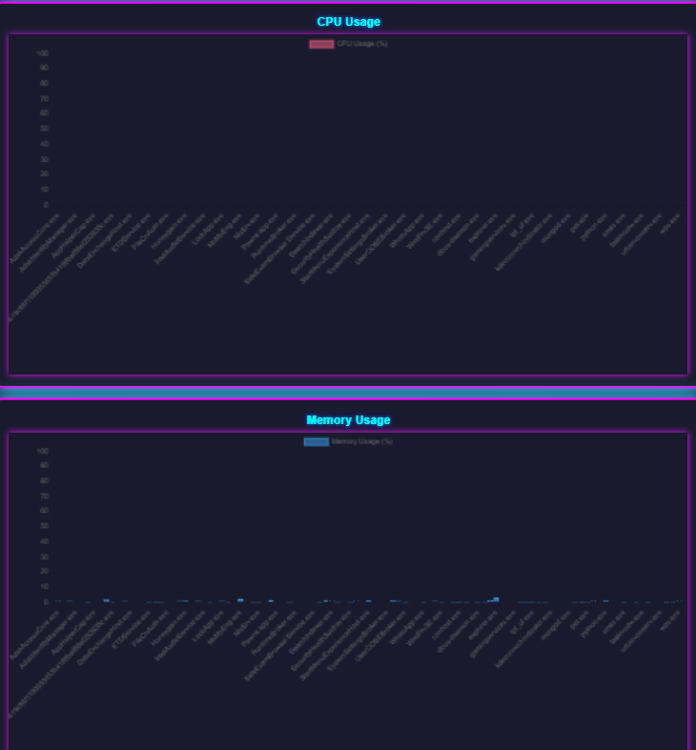
Figure 7: Behavior-Based Detection for Keylogger Identification – This figure demonstrates the detection of suspicious behavioral patterns associated with keylogger activities.

Network Based Monitoring
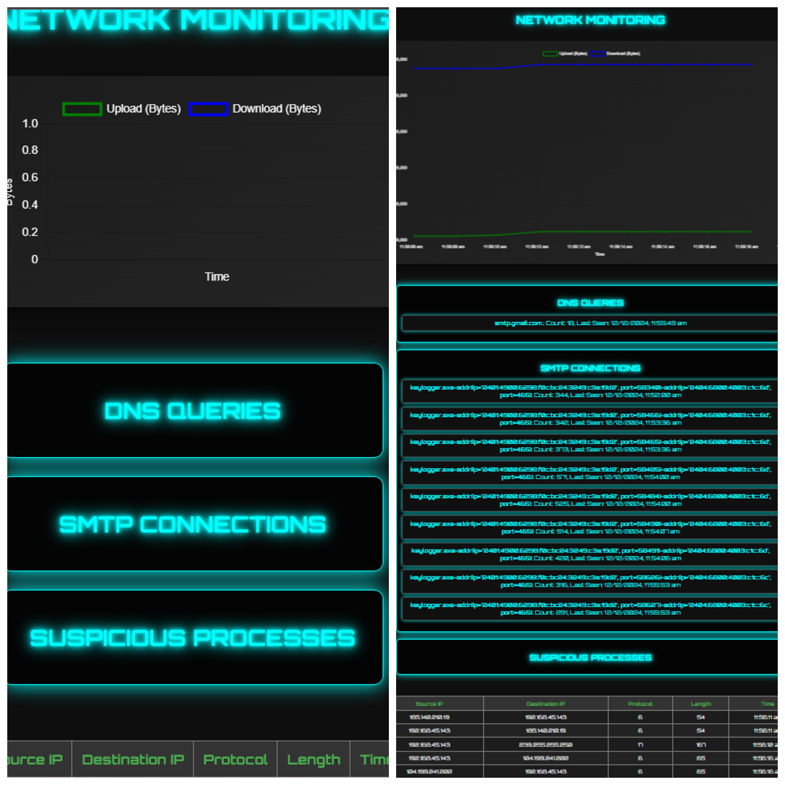
Figure 8: Network Monitoring for Suspicious Keylogger Activity – This figure shows the analysis of network traffic to identify patterns indicative of keylogger communication. .

Signature Based Monitoring

Figure 9: Signature-Based Detection and File Monitoring for Keylogger Threats – This figure highlights the use of known keylogger signatures to identify malicious processes and executable files.

FUTURE WORK

Enhanced Real-Time Detection : Real-time detection mechanisms using deep models like LSTM or CNN to analyze patterns of keystrokes and network flow could be future enhancements in further identification of evolving keyloggers.
Integration with Antivirus Solutions: A detection system that integrates with mainstream antivirus solutions could serve as a more deployable and scaleable solution across different environments due to the further protection of these applications for the users.
Improving signature databases: the YARA rule signatures can be updated often by including new malware samples. This may improve detection for newly emerging keyloggers employing obfuscation techniques.
Cross-platform compatibility : the ability of the solution to extend its keylogger detection capabilities into multiple operating systems would give much more variability and effectiveness to this solution in different environment issues.
Automated Response Systems: Future releases can integrate automated response mechanisms to automatically isolate or terminate a malicious process once detected, limiting the effects of a keylogger on the system.

Conclusion
In this project, we used a multi-layered approach to develop and detect keylogging malware. Here, the keylogger was built using Python, which captured the keystrokes and transmitted them by email, and the detection system was done with a combination of signature-based analysis (YARA rules), behavior monitoring, and machine learning (Random Forest). This combined strategy helps identify keyloggers, whether known or unknown. Unlike traditional methods that are usually based on single detection factors, our approach integrates process, file, and network monitoring for full system-level protection. Results also indicate that this hybrid model is beneficial in enhancing detection accuracy and reducing false positives, making it a solid solution against sophisticated keylogging threats. This system may further be integrated into other security frameworks to improve the level of resilience against malware.
In this research, a holistic approach was proposed for the detection of keylogging malware by integrating traditional and advanced techniques. The implementation phase included the development of a Python-based keylogger malware that could capture keystrokes and send data via email, which was then converted into an executable file using PyInstaller.
The detection phase used a combination of signature-based analysis (YARA rules), behavior-based monitoring, and advanced machine learning techniques (Random Forest). Unlike traditional approaches that rely solely on typing speed or periodic traffic patterns, this system performs in-depth monitoring of system processes, file activities, and network behavior.
The comparative analysis with existing work showed the limitations of traditional keylogger detection approaches, including: reliance on specific behavior patterns, such as typing speed or lack of system-level monitoring; the proposed solution fills these gaps by integrating multi-layered strategies for detection, which thereby improves accuracy and reduces false positives.
This study concludes that using a hybrid approach, combining signature-based, behavior-based, and machine learning techniques, will be able to significantly improve detection capabilities against changing keylogging malware. Thus, the proposed methodology will be well suited for future antivirus systems, which might be much more effective for both known and unknown cases of keyloggers.

References

- Nikhil Ingle,Shreya Agnihotri ,Kavita Devi, "KEYLOG SPY",International Journel of Novel Research and Development (IJNRD).

- Chinchalkar, R. Somkunwar, “An Innovative Keylogger Detection System Using Machine Learning Algorithms and Dendritic Cell Algorithm,” IIETA, Nov. 2023.

- Arjun Singh, Pushpa Choudhary , Akhilesh kumar singh & Dheerendra kumar tyagi ,"Keylogger Detection and Prevention",nternational Conference on Computational and Experimental Methods in Mechanical Engineering(ICCEMME) 2021.doi:10.1088/1742-6596/2007/1/012005

Make sure to remove all placeholder and explanatory text from the template when you add your own text. This text should not be here in the final version!

